Question 1/2

Create database BidvestBank;

Use BidvestBank;

create table BankBranch(

branch_name varchar(20) not null primary key,

branch_city varchar(20) not null,

assets int not null

);

create table Customer(

customer_name varchar(20) not null primary key,

customer_street varchar(40) not null,

customer_city varchar(20) not null

);

create table CustomerAccount(

account_number char(6) not null primary key,

branch_name varchar(20) not null,

balance double

);

create table Loan(

loan_number char(6) not null primary key,

branch_name varchar(20) not null,

amount double

);

create table Depositor(

customer_name varchar(20) not null,

account_number char(6) not null primary key

);

create table Borrower(

customer_name varchar(20) not null,

loan_number char(6) not null primary key

);

create table Employee(

employee_name varchar(20) not null,

branch_name varchar(20) not null,

salary double,

primary key(employee_name)

);

Question 3

insert into CustomerAccount values('A-5324','Newtown',500);

insert into CustomerAccount values('A-5324','Newtown',500);

insert into CustomerAccount values('A-7794','Midrand',900);

insert into CustomerAccount values('A-4467','Mabopane',700);

insert into CustomerAccount values('A-3546','Midrand',750);

insert into CustomerAccount values('A-3453','Universitas',700);

insert into CustomerAccount values('A-2542','Mamelodi',350);

insert into BankBranch values('Midrand','Johannesburg',7100000);

insert into BankBranch values('Newtown','Johannesburg',9000000);

insert into BankBranch values('Mabopane','Pretoria',4000000);

insert into BankBranch values('Belgravia','Kimberly',3700000);

insert into BankBranch values('Sunnyside','Pretoria',1700000);

insert into BankBranch values('Amazimtoti','Durban',300000);

insert into BankBranch values('Universitas','Bloemfontein',2100000);

insert into BankBranch values('Mamelodi','Pretoria',8000000);

insert into Customer values('Modise','Spring','George');

insert into Customer values('Brooks','Senator','Johannesburg');

insert into Customer values('Jooste','North','Kimberly');

insert into Customer values('Lombard','Sand Hill','Nelspruit');

insert into Customer values('Mokwena','Walnut','Port-Elizabeth');

insert into Customer values('Johnson','Alma','Bloemfontein');

insert into Customer values('Zwane','Main','Mafikeng');

insert into Customer values('Lindsay','Park','George');

insert into Customer values('Smith','North','Kimberly');

insert into Customer values('Dlamini','Putnam','Port-Elizabeth');

insert into Customer values('Williams','Nassau','Giyane');

insert into depositor values('Johnson','A-5624');

insert into depositor values('Johnson','A-7794');

insert into depositor values('Zwane','A-3546');

insert into depositor values('Lindsay','A-3453');

insert into depositor values('Smith','A-4467');

insert into depositor values('Dlamini','A-2542');

insert into Loan values('L-11','Mamelodi',900);

insert into Loan values('L-14','Newtown',1500);

insert into Loan values('L-15','Sunnyside',1500);

insert into Loan values('L-16','Sunnyside',1300);

insert into Loan values('L-17','Newtown',1000);

insert into Loan values('L-23','Universitas',2000);

insert into Loan values('L-93','Mabopane',500);

insert into borrower values('Modise','L-16');

insert into borrower values('Jooste','L-93');

insert into borrower values('Johnson','L-15');

insert into borrower values('Jackson','L-14');

insert into borrower values('Zwane','L-17');

insert into borrower values('Smith','L-11');

insert into borrower values('Smith','L-23');

insert into employee values('Modise','Sunnyside',1500);

insert into employee values('Brown','Sunnyside',1300);

insert into employee values('Gopal','Sunnyside',5300);

insert into employee values('Johnson','Newtown',1500);

insert into employee values('Loreena','Newtown',1300);

insert into employee values('Peterson','Newtown',2500);

insert into employee values('Roa','Austin',1500);

insert into employee values('Sato','Austin',1600);

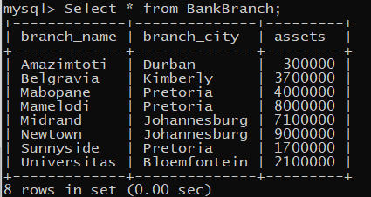

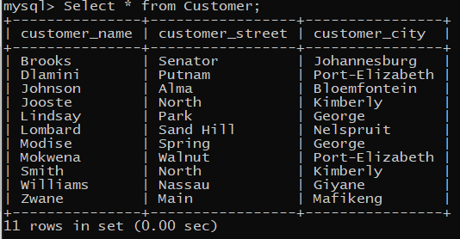

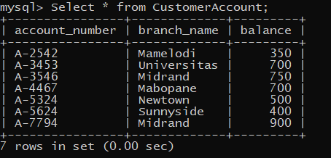

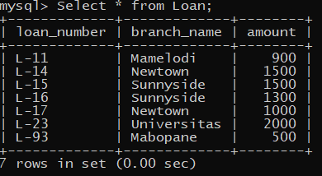

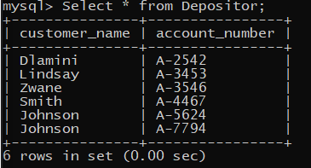

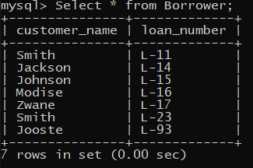

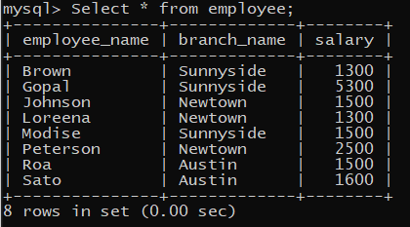

Question 4

1. The customer account numbers who have a balance above 700 are A-2542, A-5324 and A-5624 -- Select * from customeraccount where Balance < 700; 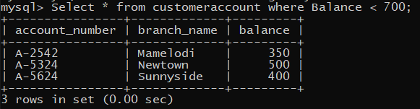
2. All the customers how live in Johannesburg are Brooks -- Select customer_name From customer where customer_city Like 'Johannesburg';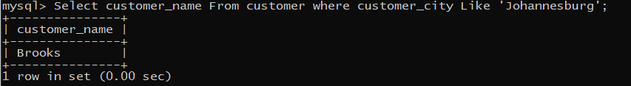
3. All the employees who have a salary greater than R1500 and don’t work in newtown are Gopal and Sato -- Select employee_name From Employee Where salary > 1500 and branch_name != 'Newtown';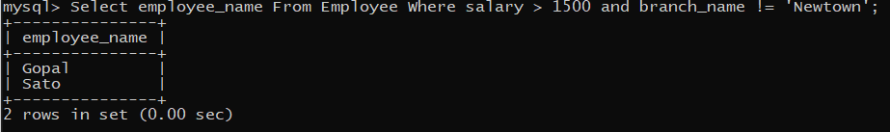
4. The average salary of the employees are R2062.5 -- Select Avg(Salary) AS 'avg_salary' from employee;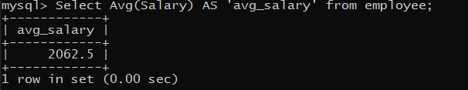
5. The bank branch with the most assets is Amazimtoti -- Select Max(assets), Branch_name from BAnkBranch;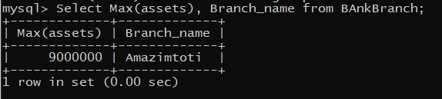

Question 5

1. The names of the employees who wotk at the Sunnyside branch are Brown, Gopal and Modise -- Select employee_name from employee Where branch_name = 'Sunnyside';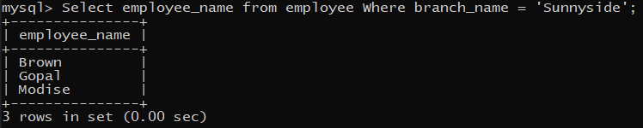
2. Select * from Borrower;
3. There are no account number where the customers balance is more than R900 -- Select account_number from customerAccount where balance > 900;
4. There are no account numbers where the branch name is Sunnyside and the balance is more than R600 -- Select account_number,balance From customerAccount Where branch_name = 'Sunnyside' And balance > 600;
5. Select branch_name,assets From BankBranch;